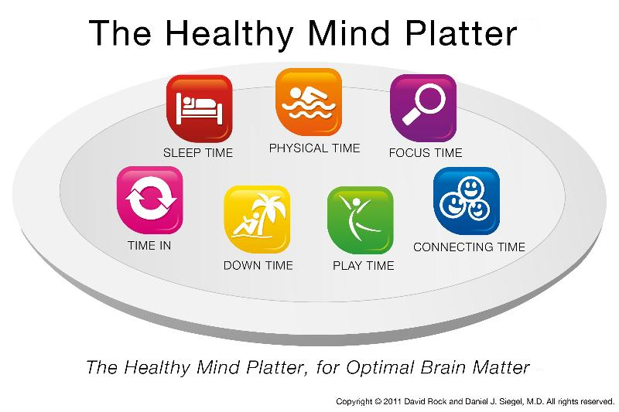

Seven daily essential mental activities to optimize brain
matter and create well-being.

Seven daily essential mental activities to optimize brain
matter and create well-being (cont.)
Focus Time | When we closely focus on tasks in a goal-oriented way, we take on  challenges that make deep connections in the brain.
Play Time | When we allow ourselves to be spontaneous or creative, playfully  enjoying novel experiences, we help make new connections in the brain.
Connecting Time | When we connect with other people, ideally in person, and when we  take time to appreciate our connection to the natural world around us,  we activate and reinforce the brain's relational circuitry.
Physical Time | When we move our bodies, aerobically if medically possible, we  strengthen the brain in many ways.
Time In | When we quietly reflect internally, focusing on sensations, images,  feelings and thoughts, we help to better integrate the brain.
Down Time | When we are non-focused, without any specific goal, and let our  mind wander or simply relax, we help the brain recharge.
Sleep Time | When we give the brain the rest it needs, we consolidate learning  and recover from the experiences of the day.

Cc Dan Siegel and David Rook

Margaret Jones Callahan MA RCC BCATR
TruePoint
Mindfulness Based Education Programs
truepnt@yahoo.ca
604-255-0131 604790-9967

True Point:
Within each of us there is a deep source of integrity, a point of personal truth that is our lodestone. It illumines the path of natural intelligence, innate wisdom, confidence and freedom.

